EET-2910
Process & Instrument Diagram

Purpose: The purpose of this exercise is to help the student understand the different components of a Process & Instrument Diagram.

Procedure:

- Create a P&ID Diagram for the Tank Dispenser System shown. Use the standard template outlined in class. Save as a PDF file and upload into the Dropbox.

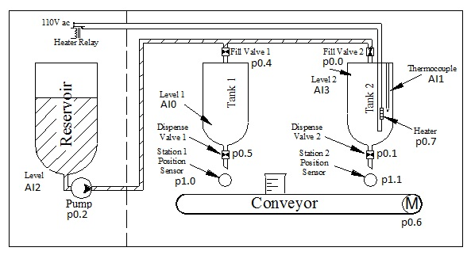

LT
2
LT
2
FY
1
FY
3
FV
3
P
ZS
5
ZY
5
FY
2
FY
4
FV
4
P
ZS
6
ZY
6
FV
1
LT
1
LT
1
LT
3
LT
3
MS
1
MY
1
CONVEYOR
M
MY
4
FV
2
MS
4
TT
3
TIC
3
FEED
TANK
TANK
#1
TANK
#2
TY
3
TE
3

